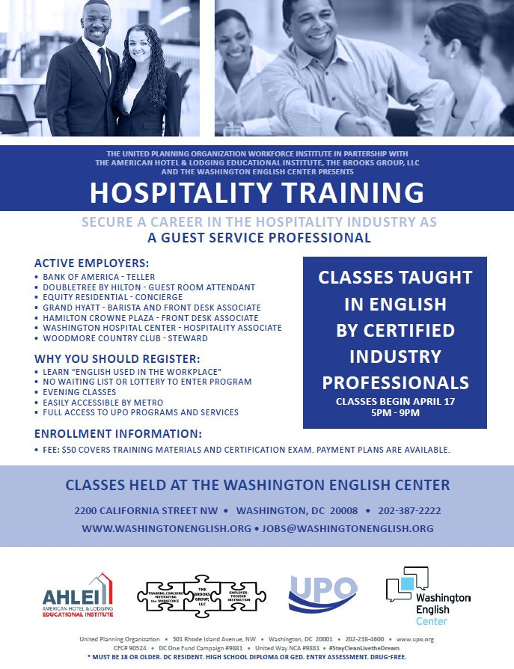
Address: 2200 California St NW Washington, DC 20008
For more information, please call (202)387-2222
or email jobs@washingtonenglish.org

